# **Business Intelligence**

# **Lab 2**

# **Case Study on Predictive Analytics**

# **of**

# **RETAIL SALES**

## **KHUSHI AGARWAL**

## **Reg No. - 2248432**

### Introduction:

Retail store is a leading global fashion retailer with a strong online presence and multiple physical stores. With a vast customer base and an extensive product catalog, Retail stores generate a wealth of transactional and customer data daily. To gain a competitive edge and make data-driven decisions, Retail stores decide to implement predictive analytics for business intelligence using Microsoft Power BI.

### Challenges:

Retail stores faces several challenges in harnessing predictive analytics for business intelligence:

1. Data Complexity: The company's data is complex and diverse, comprising sales transactions, customer demographics, website interactions, and social media engagement. Analyzing this data in real-time to uncover meaningful patterns is challenging.
2. Data Integration: Integrating data from various sources, including POS systems, e-commerce platforms, social media, and customer databases, into a unified view is essential for accurate predictions.
3. Real-time Predictions: To deliver actionable insights, predictive analytics must operate in real-time to provide timely recommendations and identify emerging trends.
4. Model Development: Building accurate and reliable predictive models requires expertise in data science and machine learning, which may not be readily available within the organization.
5. Data Security and Privacy: As customer data is sensitive, ensuring data security and compliance with data privacy regulations is a top priority.

### Solution:

To address these challenges, Retail stores adopt predictive analytics for business intelligence in Power BI.

#### STEP 1: Import the dataset to Power BI desktop

So for our Business Problem we have the dataset of a Retail Store which sells items like Electronics, Clothing and Furniture.

The 2 tables Order Details and Customer Details are connected by Order ID which is a Primary key in Order Details table and Foreign key in Customer Details.

The Order Details contains Columns: Order ID, Amount, Profit, Quantity, Category, Sub-Category, and Payment Mode for the Orders.

The Customer Details contains Columns: Customer Name, City, State, Order ID, Order Date.

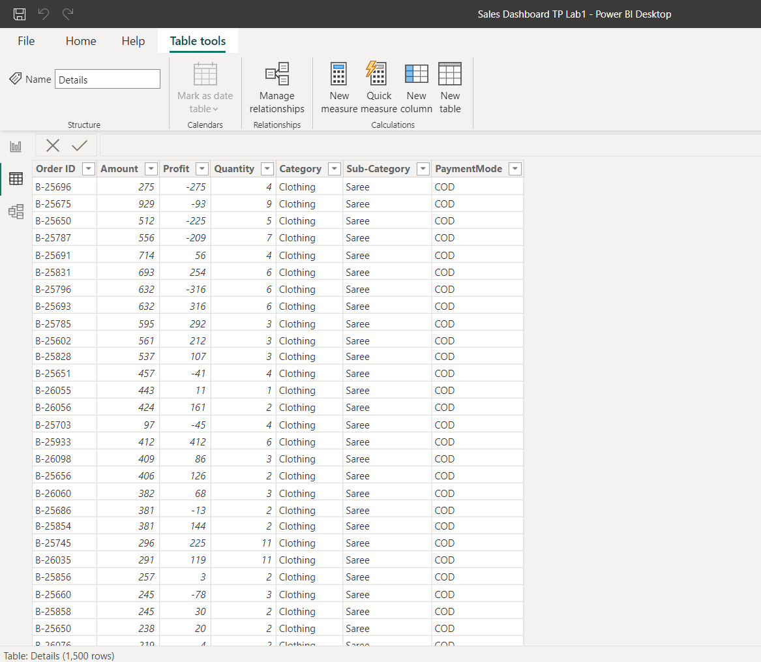

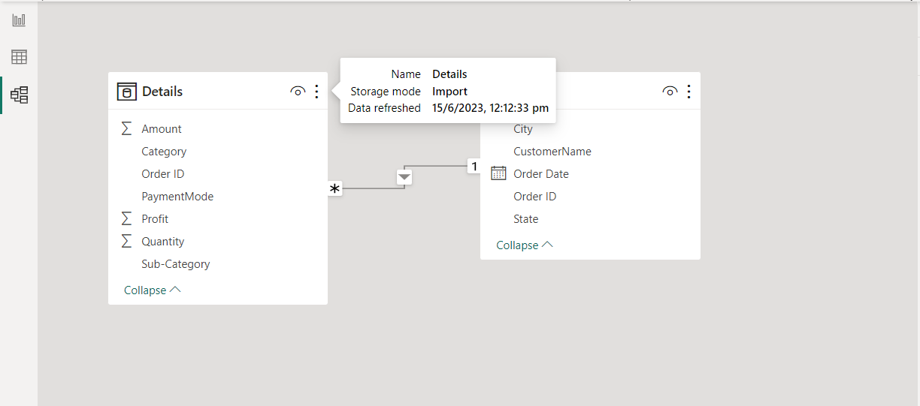

#### STEP 2: Forecast Total Profits for the next 5 months

The line graph below shows the reading of Sum of Profit through the years 2018 in

the blue line. The blue line in the blue shaded area shows us the forecasted

values of Sum of Profit in 2019. We can see, the Sum of Profit value has increased by January 2019 and then remained constant till May 2019.

We can conclude that for the next 5 months the sum of profit will increase by 2088 with an upper bound of 11709 and lower bound of -7532.

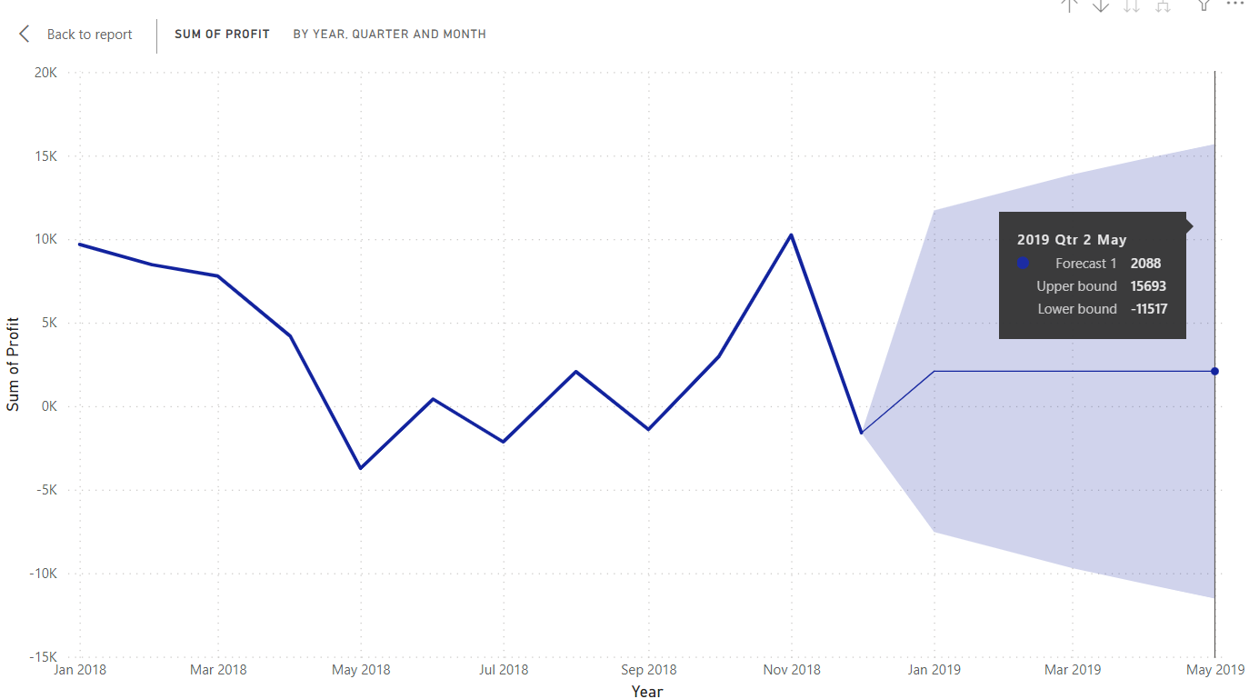

#### STEP 3: Forecast Total Profits for the next 1 months

The line graph below shows the reading of Sum of Profit date wise through the years 2018 in

the green line. The green line in the green shaded area shows us the forecasted

values of Sum of Profit in 2019. We can see, the Sum of Profit for 1st January 2019 value has decreased since the last day of December and then remained constant till 31st January 2019.

We can conclude that for the next 1 month the sum of profit will decrease by -83 with an upper bound of 721 and lower bound of -887.

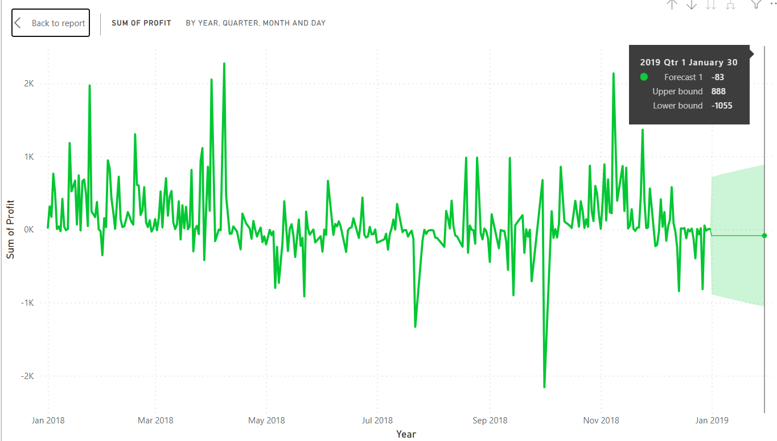

#### STEP 4: Forecast Total Amount for the next 5 months

The line graph below shows the reading of Sum of Amount through the years 2018 in

the pink line. The pink line in the pink shaded area shows us the forecasted

values of Sum of Amount in 2019. We can see, the Sum of Amount value has increased by January 2019 and then remained constant till May 2019.

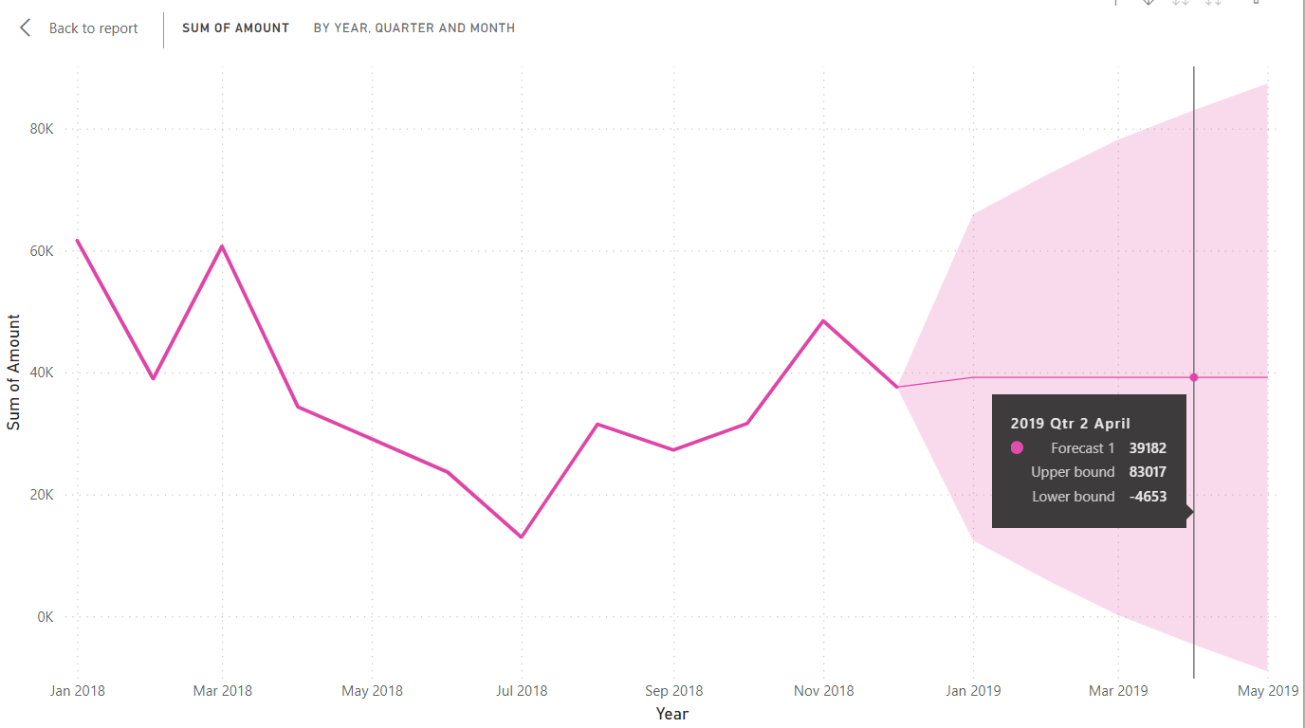

#### STEP 5: Forecast Total Quantity for the next 5 months

The line graph below shows the reading of Sum of Quantity through the years 2018 in

the orange line. The orange line in the orange shaded area shows us the forecasted

values of Sum of Quantity in 2019. We can see, the Sum of Quantity value has increased by January 2019 and then remained constant till May 2019.

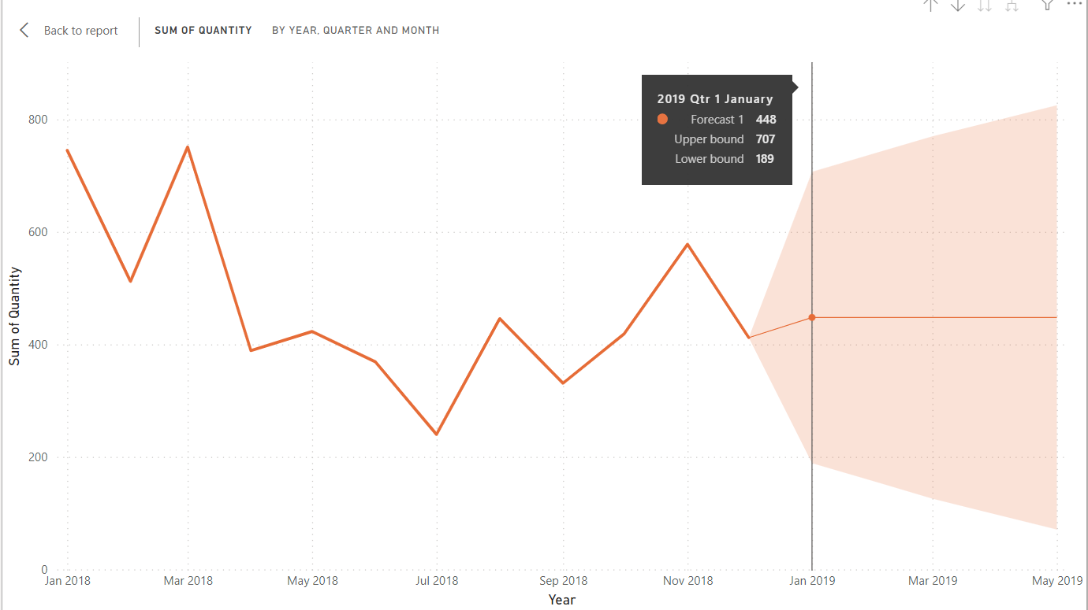

#### STEP 6: Forecast Count of Category for the next 4 months

The line graph below shows the reading of Count of Categories through the years 2018 in

the red line. The red line in the red shaded area shows us the forecasted

values of Count of Categories in 2019. We can see, the Count of Categories value has increased by January 2019 and then remained constant till May 2019.

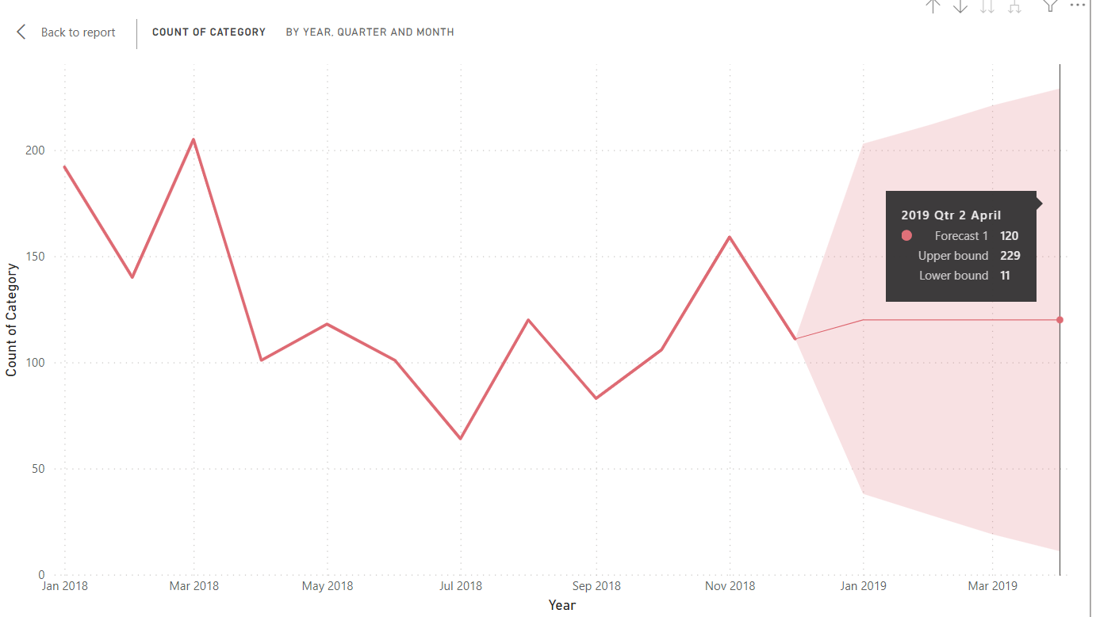

#### STEP 7: Forecast Count of Category for the next 5 months

The line graph below shows the reading of Count of Subcategories through the years 2018 in

the purple line. The purple line in the purple shaded area shows us the forecasted

values of Count of Subcategories in 2019. We can see, the Count of Subcategories value has increased by January 2019 and then remained constant till May 2019.

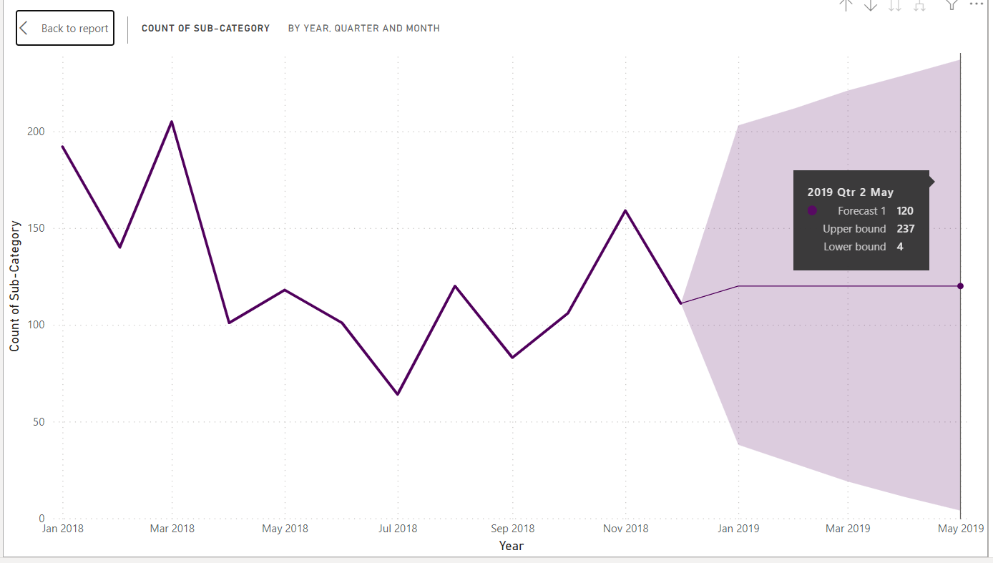

### Benefits:

The implementation of predictive analytics for business intelligence in Power BI provides Retail stores with several benefits:

1. Advanced Customer Segmentation: Predictive models enable Retail stores to segment customers based on preferences, buying behavior, and demographics. This allows the company to tailor marketing efforts and improve customer targeting.
2. Demand Forecasting: By analyzing historical sales data and other variables, predictive analytics helps Retail stores forecast demand accurately. This aids in optimizing inventory levels and minimizing stockouts.
3. Personalized Product Recommendations: Real-time predictions offer personalized product recommendations to customers, enhancing their shopping experience and increasing cross-selling opportunities.
4. Churn Prediction: Predictive analytics helps Retail stores identify potential churn among customers, allowing the company to implement targeted retention strategies.
5. Trend Identification: Real-time analysis of social media and website data helps Retail stores identify emerging trends and adapt marketing campaigns accordingly.

### Conclusion:

By leveraging predictive analytics for business intelligence in Power BI, Retail stores gain a competitive advantage by making data-driven decisions based on real-time insights. The ability to analyze vast amounts of data and predict customer behavior empowers the company to tailor marketing strategies, optimize inventory, and enhance overall operational efficiency. The success of this implementation reinforces Retail stores commitment to innovation and data-driven excellence, positioning it as a leader in the global fashion retail industry.